Lakewakes Board co.

Lakewakes boards are manufactured in the USA and are designed for all skill levels! We use virgin EPS foam for our cores that have been CNC machined to our specs. Epoxy with 4/6 S glass cloth is used for the lamination coat and all boards are vacuum bagged for a ultra strong, light weight product. There are options on how many future fins and the type of traction you want on your board. Our 2009 boards all come with a rounded nose for safety and in 4 sizes 4.2, 4.6, 4.8, 5.4” and 3 tail (diamond, round, swallow) options. Msrp start at 350.00 usd. See us at www.lakewakes.com

Diamond tail 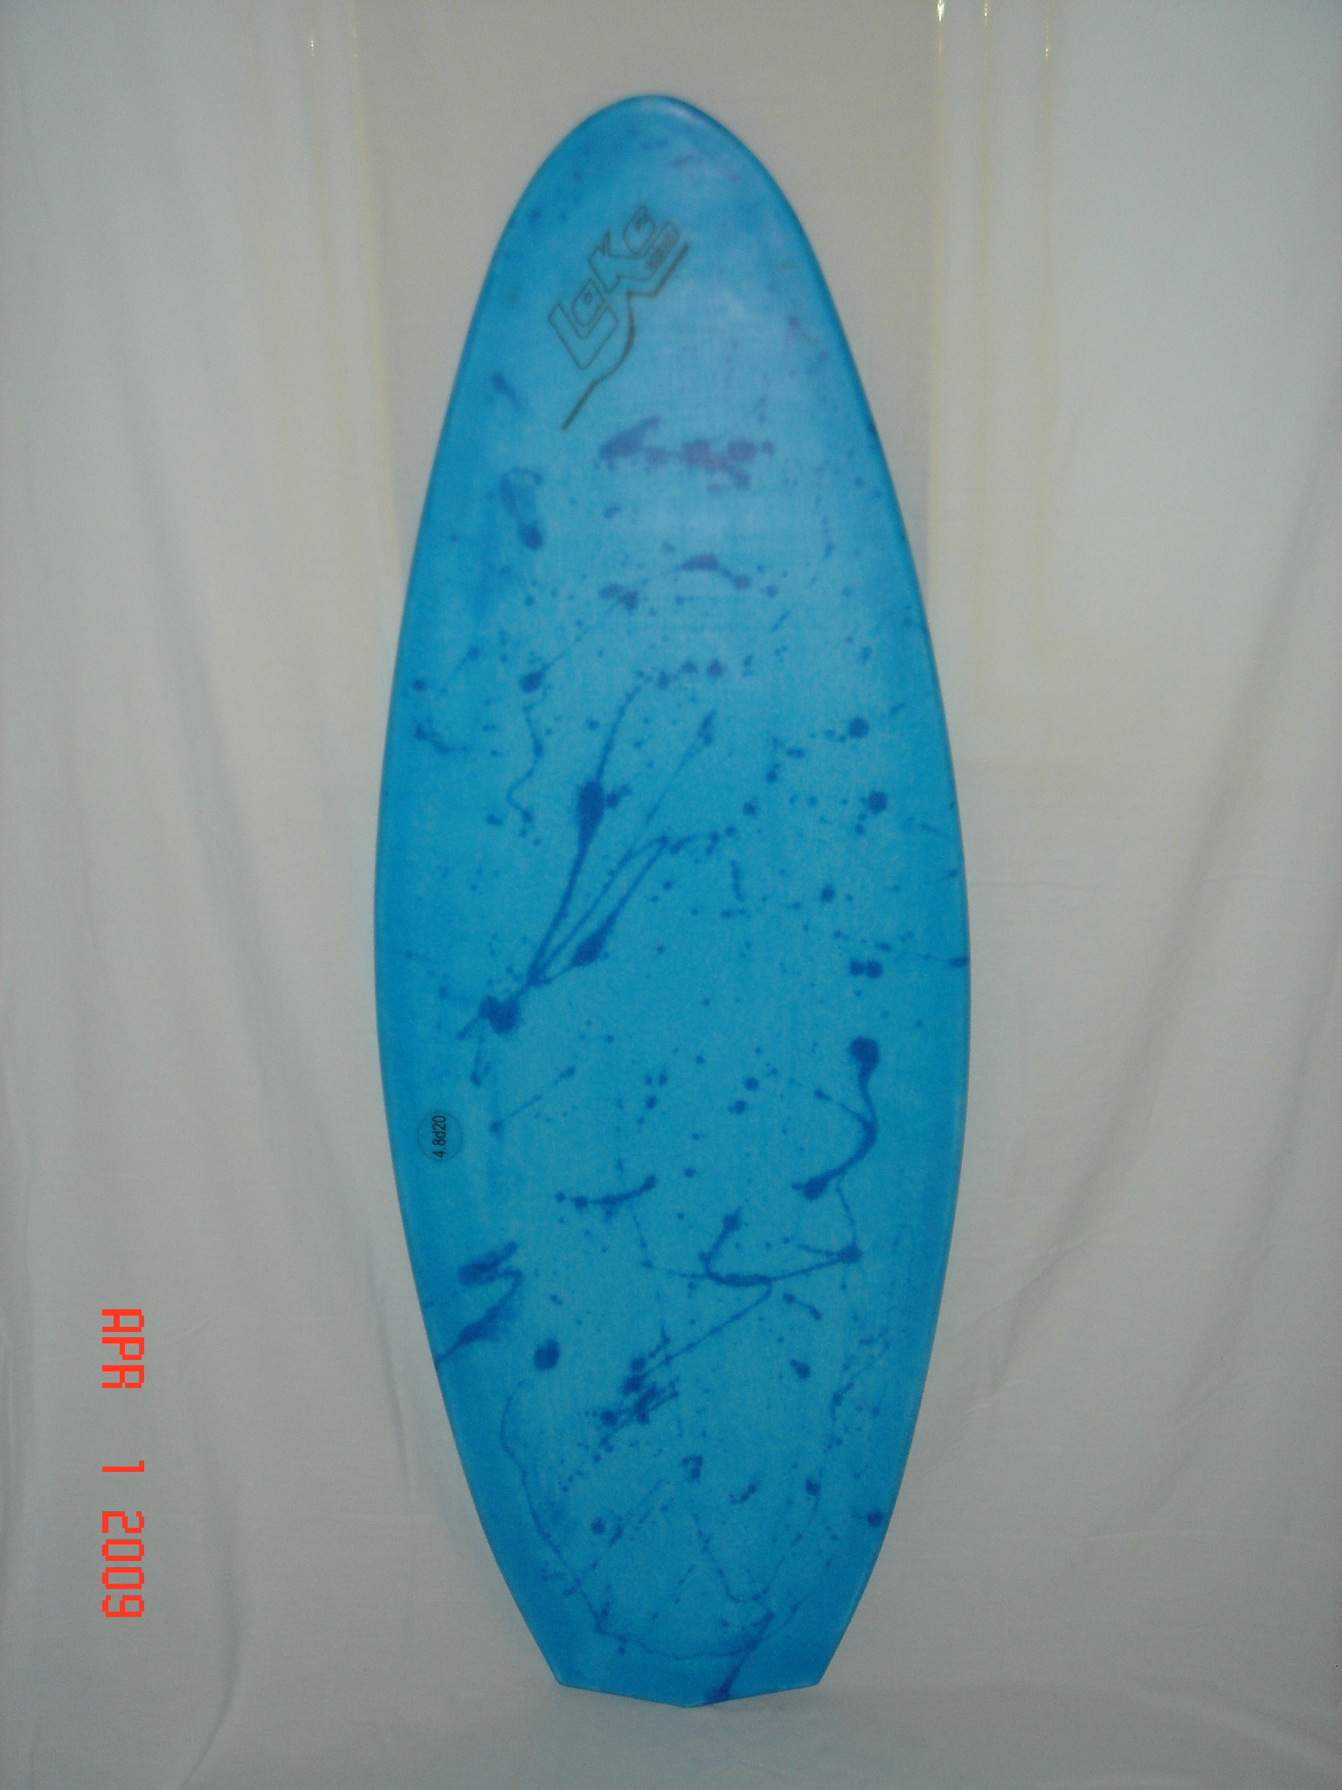
Length 4’2”, 4’8”
Width 20”
Thickness 1.125”
Rider size up to 210 lb.
Msrp 350.00 naked

Swallow tail 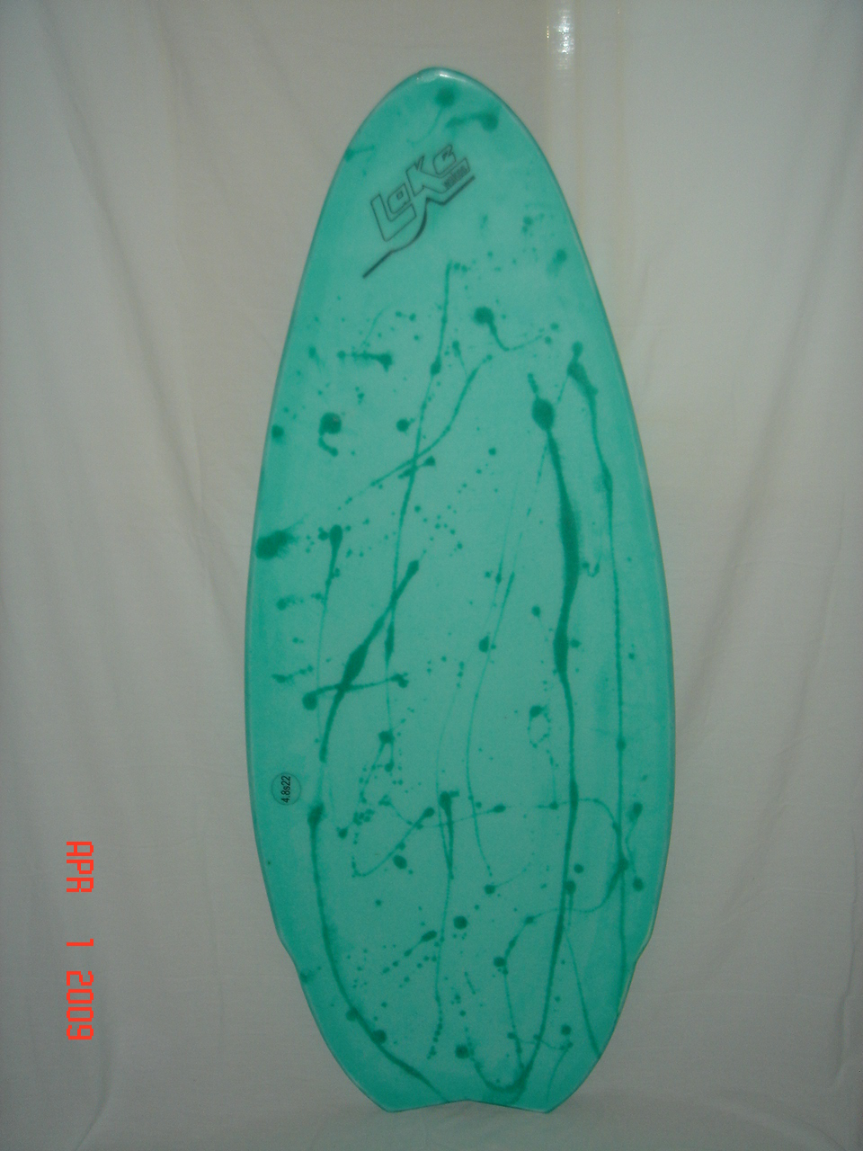
Length 4’.2”, 4’6”, 4’8”, 5’4”
Width 20”, 21”, 22”
Thickness 1.125”
Rider size up to 260 lb.on 5’4”
Msrp 350.00 naked

Round tail 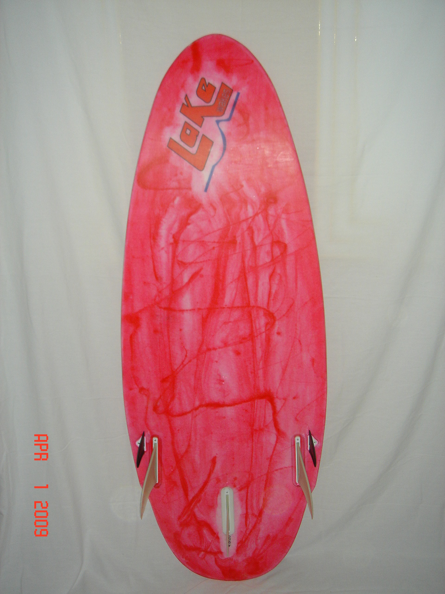
Length 4’2”, 4’6”, 4’8”, 5’4”
Width 20”, 21”, 22”
Thickness 1.125”
Rider size up to 260 lb. on 5’4”
Msrp 350.00 naked

Our boards are designed to be ridden by all skill levels by adding/subtracting fins (choose 2 to 5) for desired speed and looseness. The 3 tail shapes we offer makes the board ride to the customers style from smooth and forgiving to quick and in control. Our boards are being manufactured with flat bottoms and hard rails to the wide point which makes for a super fast ride!

Lakewakes Board co.
www.lakewakes.com
saltyoysters@lakewakes.com
478.394.2995

